School Uniform
Pupils enrolled in Abercorn Primary School are required to wear the school uniform. This is available from Robin Fields, Crorys and Maxwells.
At Abercorn PS we expect a full school uniform to be worn at all times.
The uniform consists of:
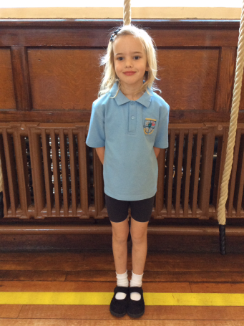
School Uniform
Blue short sleeved shirt
Navy school jumper/cardigan with logo
School tie
Navy skirt/pinafore for girls
Grey/Charcoal trousers for boys

Black shoes

Navy tights/white socks
PE Uniform
On P.E. days come to school wearing: Plain navy tracksuit bottoms or Abercorn tracksuit bottoms.
Blue polo shirt
School sweatshirt
Trainers
Navy PE shorts
P.E. plimsoles (to be kept in a PE bag in school. Please name these).
PE uniform must only be worn on PE days and school outings

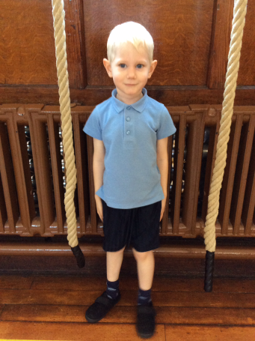

- No jewellery is permitted in school. Girls with pierced ears can wear one simple stud in each ear.
- During the summer months a blue and white gingham summer dress may be worn with the school jumper/sweatshirt. Boys may wear grey/charcoal shorts and blue polo shirt with the school sweatshirt.
- All items of uniform and personal property must be clearly labelled.
- Hair accessories must be very simple in navy or black. Summer gingham hair accessories are also acceptable with summer dresses.

